M.V.P. Samaj’s
S.S.S.M. Arts, Science and Commerce College, Saikheda
Tal.- Niphad, Dist.- Nashik
Department of Botany

Best Practices: Plant of the Month
Academic Year: 2024-25

Introduction: Introducing a "Plant of the Month" initiative on college campus for F.Y., S.Y. and T.Y.B.Sc., Botany Students offers numerous benefits, including environmental education, beautification of campus spaces, and fostering a sense of community engagement. This report outlines best practices for implementing and maintaining a successful Plant of the Month program in a college setting. In our college Botany department initiate this activity for Botany subject students. The format of activity is display living plant with their written information on poster. This activity started during the academic year 2023-24.
Selection Criteria: Establish clear criteria for selecting plants to feature as Plant of the Month, considering factors such as seasonal relevance, sustainability, native species, and aesthetic appeal. Engage students, faculty, and staff in the selection process to ensure diversity and inclusivity in plant choices and to promote community ownership of the program.
Educational Content: Develop educational materials and resources to accompany each Plant of the Month feature, including information about the plant's botanical characteristics, habitat, ecological significance, and cultural relevance. Utilize signage, digital displays, social media platforms, and campus newsletters to disseminate educational content and engage the campus community in learning about the featured plants.
Interactive Engagement: Organize interactive activities and events related to the Plant of the Month, such as guided botanical tours, plant identification workshops, gardening demonstrations, and hands-on planting sessions. Encourage student involvement through volunteer opportunities, internships, research projects, and student-led initiatives related to horticulture, botany, and environmental conservation.
Sustainability Practices: Prioritize sustainable gardening practices in the selection, cultivation, and maintenance of plants featured in the Plant of the Month program, including organic gardening methods, water conservation, and integrated pest management. Educate the campus community about the importance of sustainable landscaping and biodiversity conservation in mitigating environmental challenges such as climate change, habitat loss, and species extinction.
Evaluation and Feedback: Establish mechanisms for evaluating the effectiveness and impact of the Plant of the Month program, including surveys, focus groups, and qualitative feedback from participants. Use evaluation data to assess program outcomes, identify areas for improvement, and inform future planning and decision-making processes.
Conclusion: Implementing a Plant of the Month program on college campuses provides a unique opportunity to promote environmental awareness, engage the campus community, and enhance the aesthetic appeal of campus landscapes. By adhering to best practices such as thoughtful plant selection, educational content development, interactive engagement, sustainability practices, and evaluation and feedback mechanisms, colleges can create a vibrant and impactful program that enriches the college experience for students, faculty, and staff alike.
Editorial Board:
Teacher editor
Name of Faculty | Designation
Prof. (Dr.) S.A.Khairnar | Principal
Dr. S.V.Gosavi | HOD and Asst. Professor
Dr. M.G.Gavit | Asst. Professor
Mr. B.S. Kale | Asst. Professor
Miss. R.M. Shinde

Student editorial Board
Sr.No. | Name of the Students | Class
 | Jadhav Prachi Suresh | T.Y.B.Sc.
 | Kurane Sanket Arun | T.Y.B.Sc.
 | Rayate Vinod Daulat | T.Y.B.Sc.
 | Borade Prachi Bhausaheb | T.Y.B.Sc.
 | Deshmukh Komal Shantaram | T.Y.B.Sc.
 | Kadam Abhishek Sharad | T.Y.B.Sc.
 | Khalkar Nikita Sanjay | T.Y.B.Sc.
 | Kute Sanika Ambadas | T.Y.B.Sc.
 | Palde Nikita Ashok | T.Y.B.Sc.
 | Khalkar Snehal Punjaram | T.Y.B.Sc.

Dr. S. V. Gosavi

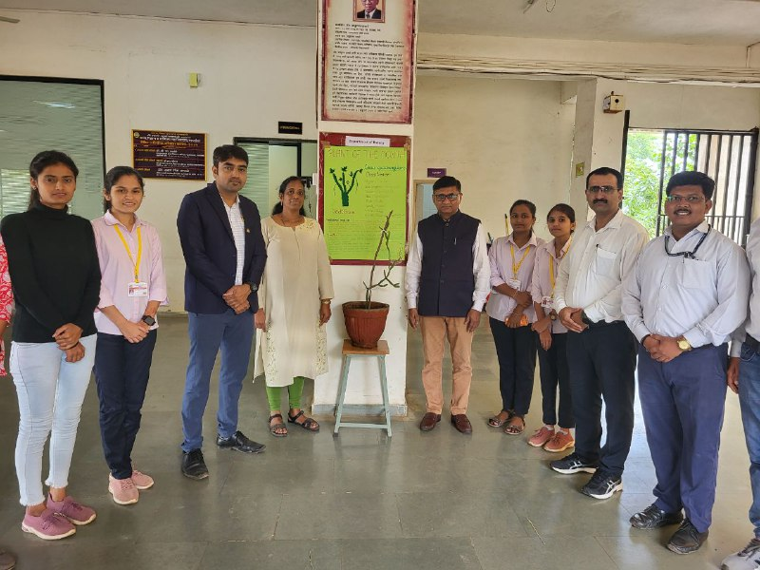
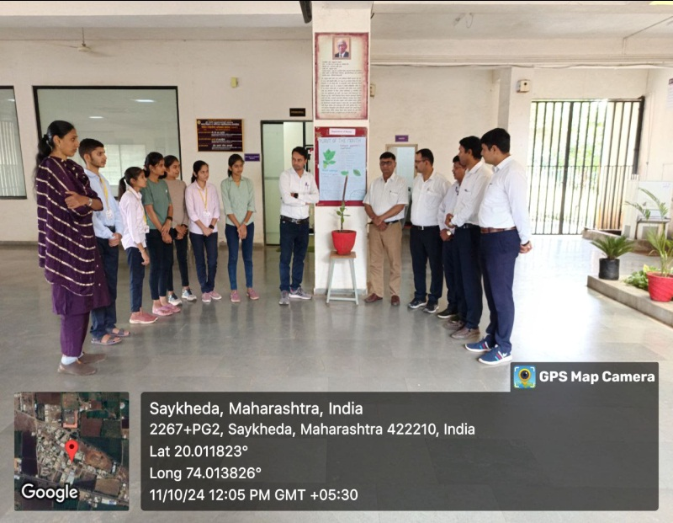
Photo Plates
